Adding a Certificate

It is not sufficient to check out a contract with certificates alone, you still need to open a contract with a pre-authorized payment method (i.e. credit card, direct bill, cash). To record a rental certificate in a contract, simply go to the Payment screen and click on the Voucher/Certificate button to bring up the Voucher/Certificate window (See Figure 1). Select ‘Certificate’ from the Type drop down list.

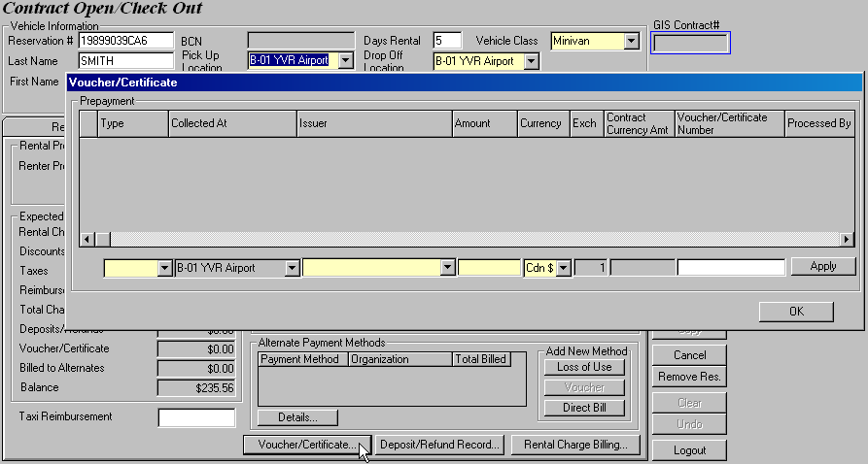
Figure 1: Open the Voucher/Certificate window to add rental certificates to a contract.

NOTE
The Voucher/Certificate window will only process certificates for now as the “Voucher” implementation is not ready on production.

Budget Rent-a-Car of B.C. Ltd. accepts rental certificates from the three issuers below:
- AM RENTAL CERTIFICATE PROGRAM
- BUDGET RENTAL CERTIFICATE
- HILTON HHONORS REWARD RENTAL CERTIFICATE

Let’s start by adding a CDN$250 Air Miles Rental Certificate. Select ‘AM RENTAL CERTIFICATE PROGRAM’ from the Issuer field, and notice that the Voucher/Certificate Number field automatically changes to a required field. Enter the amount on the renter certificate presented by the customer in the Amount field. A rental certificate is similar to a cash payment, and like cash, you can select the currency of your rental certificate and GIS will automatically convert any US certificates into Canadian dollars. The default currency is always CAD so we will leave it as is. Finally, enter the certificate no. in the Voucher/Certificate Number field and click Apply. The Air Miles certificate will then be added to the Prepayment grid above. As per the rule set by Virginia Beach, we can only honor one type of certificate per contract so we restrict each contract to only accept certificates from ONE issuer on GIS. Therefore, once a certificate is added to the contract, the Issuer field is immediately grayed out and disabled (See Figure 2). With the Issuer field grayed out, you can still proceed to adding more certificates of the same issuer if necessary – just select ‘Certificate’ from the Type column again and you will see that Issuer automatically defaults to the issuer of the previously added certificate, which is the AM RENTAL CERTIFICATE in our case.

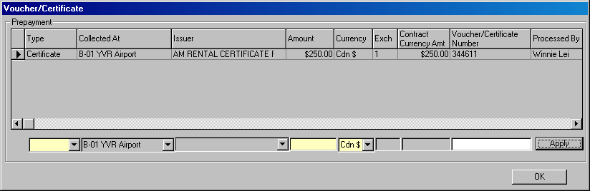
Figure 2: The Issuer field becomes disabled once a certificate is added to the grid.

You can add as many certificates as required in GIS, so long as they are from the same issuer. The total certificate amount is recorded in the Voucher/Certificate field on the Payment screen, as shown in Figure 3.

TIP!
If you need to enter a lot of certificates with consecutive certificate numbers, e.g. 344611, 344612, 344613, 344614, 344615, you can just add up their rental certificate amount in the Amount field and enter the range of certificate numbers in the Voucher/Certificate Number field like this: 344611 – 344615.

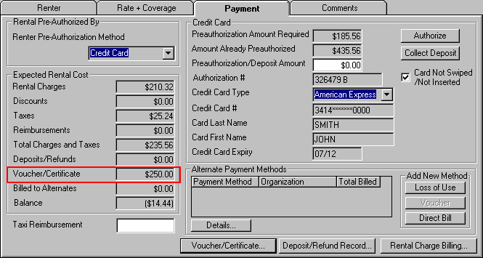
Figure 3: The Voucher/Certficate field displays the total amount of certificates that were used in the contract.

IMPORTANT
All certificates must be added in the Voucher/Certificate window. Do not split the rental charges manually and assign them to direct bill to reach the rental certificate amount.

You may add certificates to all contracts except those which contains a BCD number of
A571600 (AIR MILES LOYALTY GRP) because certificates cannot be combined with Air Miles redemption bookings.

Removing a Certificate

Removing a certificate is exactly the same as adding a certificate. The only difference being, you enter a negative amount instead of a positive one. So if we want to remove the Air Miles certificate we just added in the previous section, populate all the fields like how we added the certificate and change the amount to -$250. Click Apply and the certificate is removed, as shown in Figure 4. The Voucher/Certificate field on the Payment screen also becomes $0 following the removal of the Air Miles certificate.

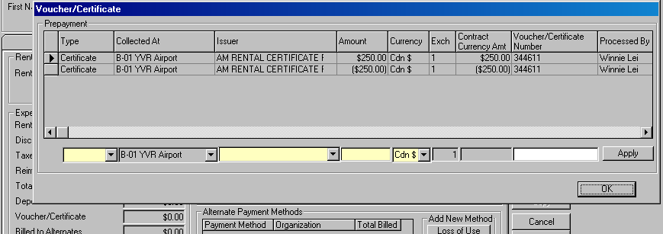
Figure 4: The Voucher/Certficate field displays the total amount of certificates that were used in the contract.

Recall that each contract accepts certificates from only one issuer. After we removed the certificate issued by Air Miles, the contract no longer has any certificate attached to it, so the Issuer field becomes available again for selection.

In other words, you cannot change the Issuer field as long as the total certificate amount for an issuer is not $0.
Closing a Contract with Certificate

Let’s check in the contract with the Air Miles certificate from our previous example. Notice that since the certificate is able to cover the entire rental cost, no charges are required for the credit card and therefore the Payment Amount is $0. The fine print on the certificate states that it is non-refundable and since the rental certificate amount is not used in its entirety, the unredeemed portion of the certificate is displayed in the Non-Refundable Balance field (See Figure 5). As usual, when Payment Amount is $0, you can check in your contract.

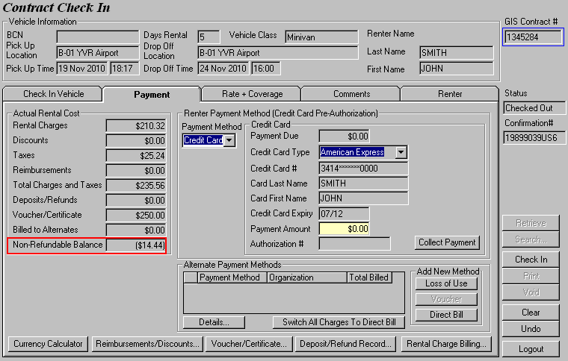
Figure 5: The unused portion of the certficate(s) is displayed in the Non-Refundable Balance field.

Once you hit the Check In button, GIS automatically converts the Non-Refundable Balance into a manual rental charge billing item called ‘Unredeemed Prepayment’. Remember this charge item as it will come in handy when you do adjustments. The Total Charges and Taxes for the contract is then updated to reflect the added manual rental charge billing item from the unused certificate portion, as shown in Figure 6. The contract printout has also been modifed to accommodate this change, see the attached sample contract agreement and receipt for contract #1345284.

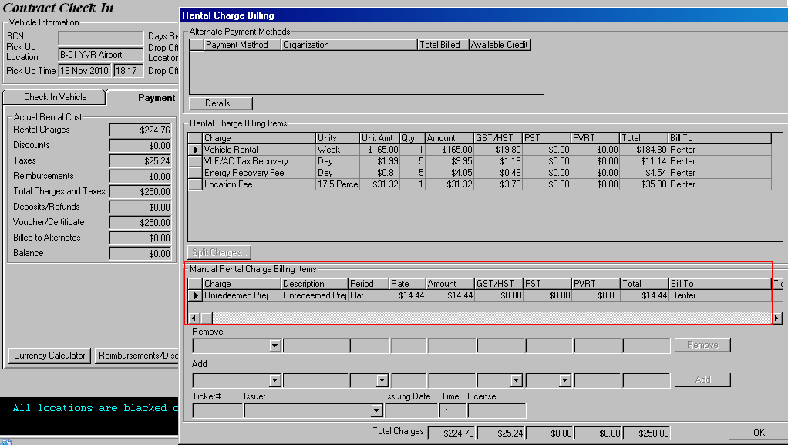
Figure 6: GIS converts the unused portion of the certificate into revenue by turning it into a charge item.

In most cases (See Figure 7), however, contract charges cannot be paid in full with just rental certificates and you would have to collect the outstanding balance on the credit card authorized for the rental. So click Collect Payment and proceed to close the contract.
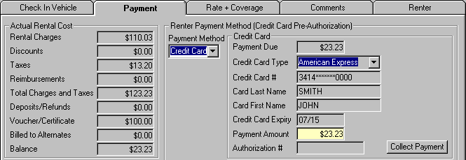
Figure 7: GIS will only allow you to checkin once the outstanding amount has been collected.

Consider another scenario where the rental is paid in excess due to both customer deposit and the use of rental certificates. When rental certificates are in the picture, the order of deducting the total rental charges off different payment methods becomes very important. GIS will always deduct the total rental charges of certificates before other method of payments.

Take a look at Figure 8 below. The rental charges adds up to $1916.33 and we have a deposit of $1000 and $1000 of rental certificates. What GIS will do in this case is use the $1000 rental certificate to pay for the entire rental and charge the rest to the customer’s credit card on file. Since we have collected far more than needed, we must refund the remaining balance to the credit card before we can close the contract.

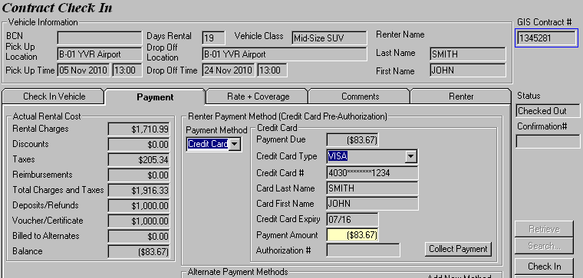
Figure 8: Payment must be refunded through the Deposit/Refund Record screen before you can close the contract.

Adjusting a Contract with Unused Certificate Amount

It is possible to redeem the unused portion of rental certificates in Contract Adjustment for any additional charge items.

We will reuse contract 1345284 (with an unused Air Miles certificate amount of $14.44) from our previous example. Let’s add a fuel charge of $9.00 to the contract. Recall that GIS will automatically create a manual rental charge item called “Unredeemed Prepayment” for any unused certificate amount so this is where you will deduct the fuel charge (plus location fee) from, as shown in Figure 9. It’s that simple.

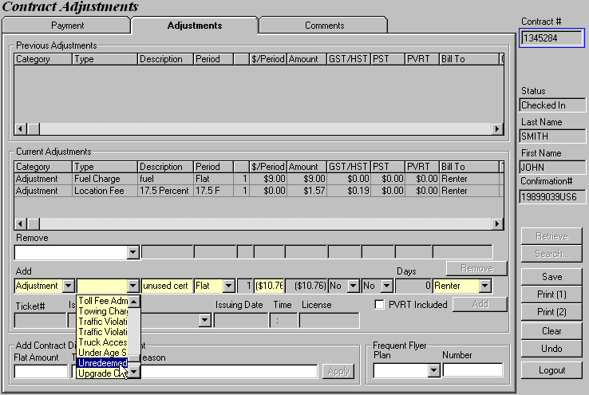
Figure 9: Paying for fuel using the unused certificate amount by deducting it from ‘Unredeemed Prepayment’.

After you click Add, switch to the Payment tab and observe that the Collect/Refund Amount is $0. Now you can save or print the updated contract.

If the unused certificate amount is not enough to cover the adjustments, charge the outstanding amount to the credit card on file.

